Jamie’s Run for Connecticut Children’s
Social Media Ambassador Tool Kit
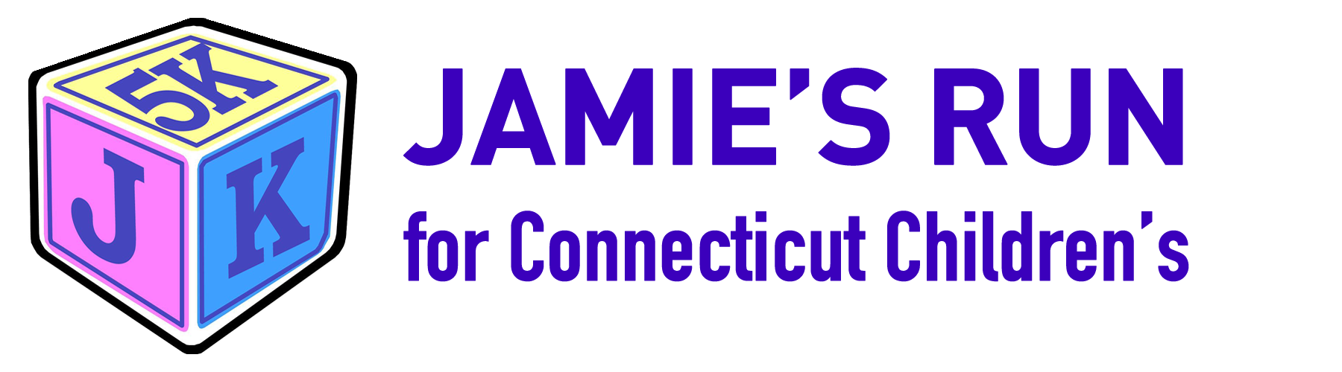
Thank you for serving as a Social Media Ambassador for Jamie’s Run and Connecticut Children’s Medical Center! As a Social Media Ambassador, you play a vital role in helping to promote this inspiring event and its mission in supporting children throughout the region and across the globe. As you look to share your role in our event online, please feel free to reference this tool kit for best practices and sample posts to help maximize your reach on social media.
Best Practices
- Like and share Jamie’s Run Facebook page and posts - Facebook.com/Jamiesrun
- When posting, please be sure to use following hashtags:
  - #jamiesrun
  - #CTChildrens
  - #endchildhoodcancer
  - #Run4CTChildrens
This allows us to know when you are posting about us and to connect with others!
- Social Media Handles
The following handles should be used as appropriate. When posting to…
  - Facebook and LinkedIn: @jamiesrun @ConnecticutChildrens
  - Instagram: @jamiesrun @CTChildrensMedCtr
  - Twitter: @jamiesrun @CTChildrens
- The Jamie’s Run web page should accompany each post so your followers have a link to click for registering, fundraising and more information. That url is: www.jamiesrun.org and can be added to the end of each post.
- When possible, an image should always accompany a post. This will help Facebook prioritize your post in the social feeds of your friends and family. Please look to this tool kit for the appropriate photos to do so.

- When to share?
  - Anytime, anywhere!
  - These are the best times to post by platform
    - Facebook: Thursdays and Fridays (Between 9AM & 7PM)
    - Twitter: Wednesdays, Saturdays & Sundays (12PM, 1PM & 6PM)
    - Instagram: 7 Days a Week (Between 3 & 4PM)
    - LinkedIn: Tuesdays, Wednesdays & Thursdays (Between 10AM & 11AM)

SAMPLE POSTS
Feel free to copy and paste the following posts to your personal Facebook, Instagram or LinkedIn pages with the designated photo. *Please note, because Twitter has a 140-character limit, it has been designated a specific section of content, which can be found at the end of this tool kit.

- On November 4th, you'll join more than 1,000 runners, walkers and fun runners in Connecticut Children's largest 5K road race event! This inspirational morning features music, inflatables, refreshments, kids’ activities, mascots and more. The 5K certified course is fast and flat - a great Manchester Road Race qualifier - and circles the historic Wethersfield Town Green. The JK Kids K is one of the largest fun runs in the area and is chip timed with amazing LEGO prizes in 4 age categories!

Jamie Knotts was only 5 months old when she passed away from a rare liver cancer. Over the past seven years, Jamie's Run has raised more than $380,000 for Cancer Clinical Trials and Family Support Programs at Connecticut Children's in her name. #ctchildrens #Run4CTChildrens #jamiesrun #endchildhoodcancer

- On November 4th, you’ll join more than 1,000 runners, walkers and fun runners in @ConnecticutChildrens largest 5K road race event. @JamiesRun welcomes runners and walkers at any level, from the recreational trotter to the experienced road racer. Register today at jamiesrun.org. #ctchildrens #Run4CTChildrens #jamiesrun #endchildhoodcancer
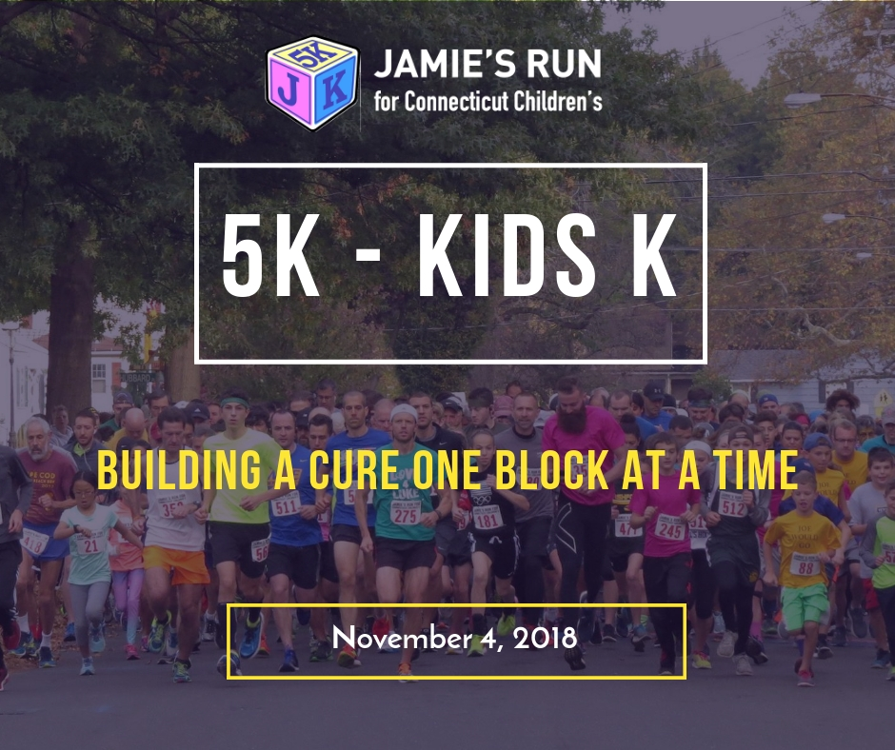
- Jamie's Run - Letting Kids be Kids - Running for Carly!
Carly is your typical 13 year old. She enjoys spending time with her friends, doing crafts and travelling with her family. She also has cancer. Carly has been battling a rare brain tumor at Connecticut Children's Medical Center for 3 ½ years. Throughout her treatment and recovery, Carly’s amazing medical team worked tirelessly to keep her life as normal as possible. She has been able to stay in school and continue doing all of the things she loves. Carly appreciates all those who have taken such good care of her and thanks you for helping provide world-class cancer care right here at Connecticut Children's Medical Center. She spends a lot of her free time thanking those who have made her journey a little easier - so thank you!
Run for Carly and register for the 9th Annual Jamie's Run for Connecticut Children's and skip the lines on Sunday morning. bit.ly/jamiesrun #jamiesrun#run4ctchildrens #gogoldforchildhoodcancer
#jamiesrun #GiveCTChildrens #Run4CTChildrens #endchildhoodcancer

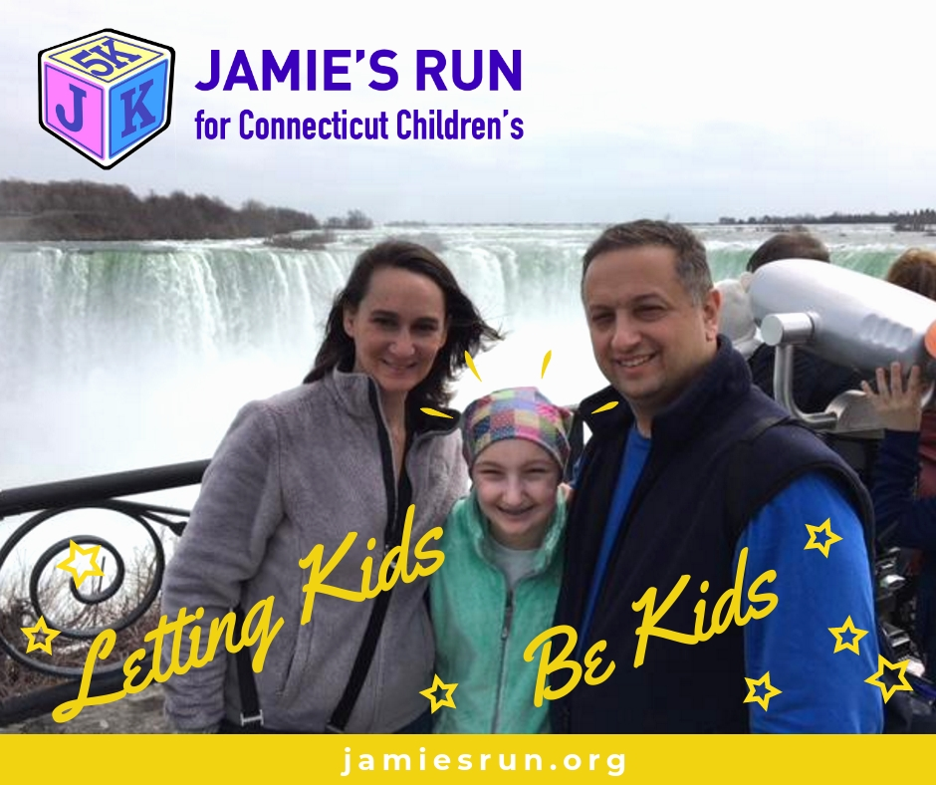

Donations Post
- I’m proudly participating in Jamie’s Run for Connecticut Children’s 5K in Wethersfield on November 4. Please consider making a gift to my team – no dollar amount is too small - because every penny means HOPE for families like Ian’s. Just follow this <link> and make a gift today. #jamiesrun #CTChildrens #Run4CTChildrens #endchildhoodcancer

Twitter Specific Posts
- Join me @jamiesrun 5K and Kids K on 114 & let’s make dreams of health & happiness come true for all children. #jamiesrun #Run4CTChildrens
- Ask me about @jamiesrun 5K and Kids K – I’m #jamiesrun #Run4CTChildrens
- I support @jamiesrun 5K and Kids K because I want all children to have access to the best treatments. #jamiesrun #Run4CTChildrens

